# Reboot Camp 2023 Arduino Workshop

Contents

Reboot Camp 2023 Arduino Workshop 1

How to Connect your Arduino to the Computer and Upload a Program 2

Arduino Print to Computer via Serial 5

Arduino LED Toggle 7

Arduino LED Blink Program 8

Arduino Traffic Controller 9

Arduino Blinking Smiley Face 11

Arduino Digitshield and Matrix Graphics 13

Arduino Joystick Calibration 14

Arduino Arcade – Pong 15

Arduino Arcade – Space Invaders Part 1 19

Arduino Arcade – Space Invaders Part 2 22

# How to Connect your Arduino to the Computer and Upload a Program

1. Connect the USB cable to the PC and the Arduino

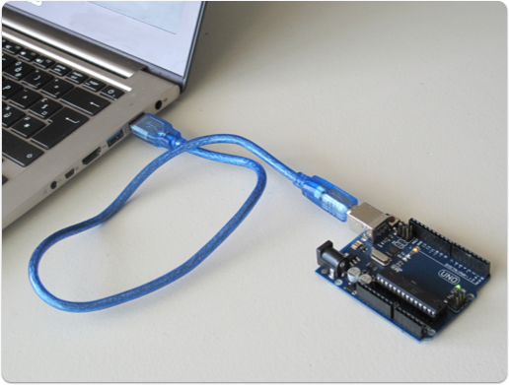

1. Open the Arduino IDE



1. Click on to “Tools” >> “Port:”,
2. Select one of the options available labelled with “COM#” – For example “COM1”, “COM4”, or similar ones.  
   If this does not work, try another option.  
   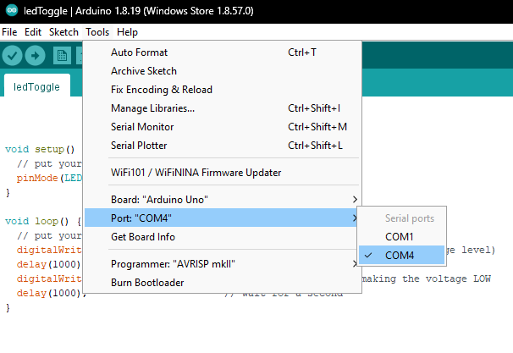
3. To check to see if the code will upload to the Arduino, first click on the “Verify” button.

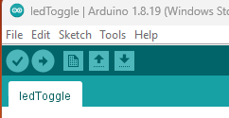



1. If an error occurs, you will need to fix your Arduino code.   
   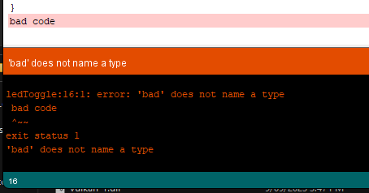
2. If the “Verify” works with no error, you then upload your code to the Arduino.  
   To upload the code to the Arduino, click on the “Upload” button.  
   



1. The Arduino will then start working with your code!

# Arduino Print to Computer via Serial

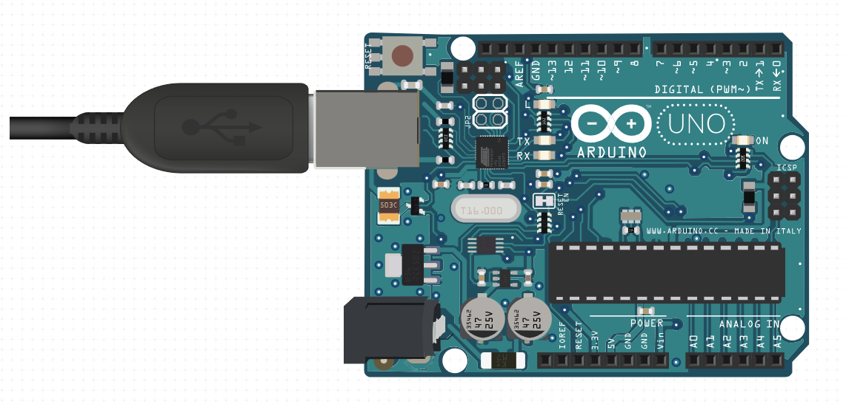

To start this one, open Serial Monitor via: “Tools” >> “Serial Monitor”  
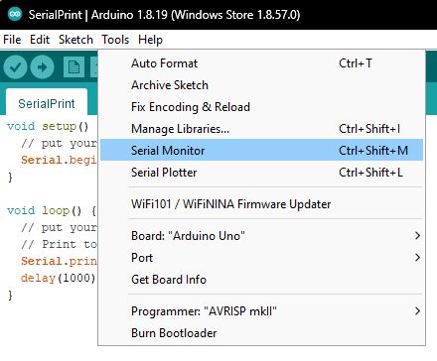

void setup() {

 // put your setup code here, to run once:

**Serial**.begin(9600);

}

void loop() {

 // put your main code here, to run repeatedly:

 // Print to serial every second

**Serial**.println("Hello World!");

 delay(1000);

}

When you run the code, the Serial Monitor will print out what you want it to write!

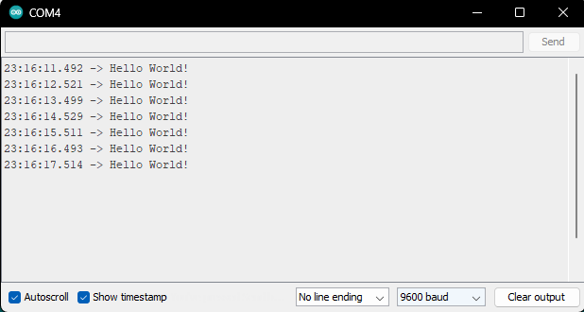

Challenge Task:

Print your name to the Serial Monitor every 3 seconds.

# Arduino LED Toggle

This code toggles an LED on the Arduino in 1 second intervals.



void setup() {

 // put your setup code here, to run once:

 pinMode(LED_BUILTIN, OUTPUT);

}

void loop() {

 // put your main code here, to run repeatedly:

 digitalWrite(LED_BUILTIN, HIGH);   // turn the LED on (HIGH)

 delay(1000);                       // wait for a second

 digitalWrite(LED_BUILTIN, LOW);    // turn the LED off (LOW)

 delay(1000);                       // wait for a second

}

Challenge Task:



Make the LED blink 3 times quickly, then stop for 2 seconds.

# Arduino LED Blink Program

This code will blink an LED attached to pin 5 every second.

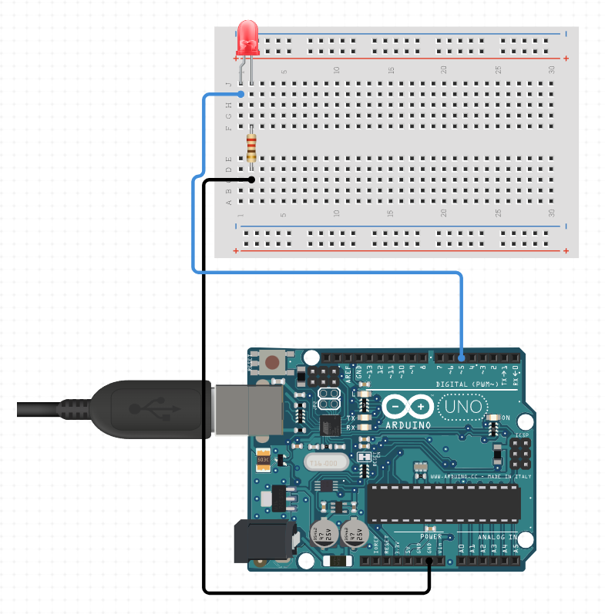

int ledpin = 5;  // This is the pin the LED connects to.

void setup() {

 // put your setup code here, to run once:

 pinMode(ledpin, OUTPUT);

}

void loop() {

 // put your main code here, to run repeatedly:

 digitalWrite(ledpin, HIGH);   // turn the LED on (HIGH)

 delay(100);                       // wait for a second

 digitalWrite(ledpin, LOW);    // turn the LED off (LOW)

 delay(1000);                       // wait for a second

}

Challenge Task:

Connect the LED to pin 9, then get the code it to work with the new pin.

# Arduino Traffic Controller

This program will act like traffic lights!

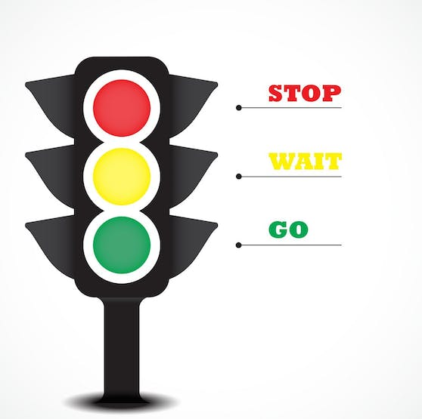

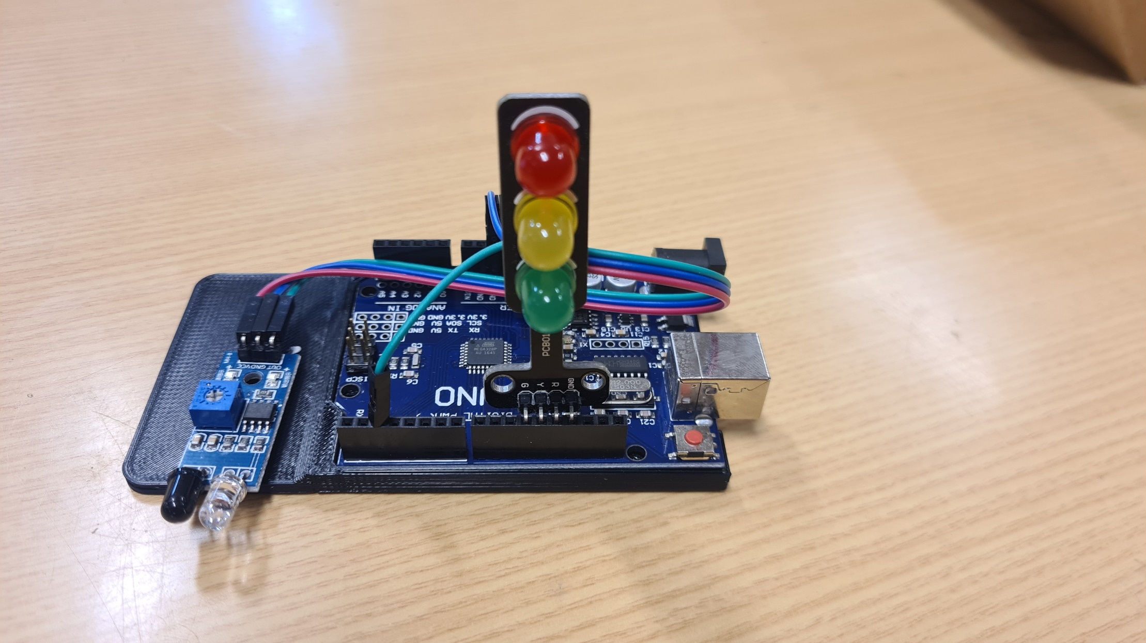

int redlight = 13;

int yellowlight = 12;

int greenlight = 11;

void setup() {

 // put your setup code here, to run once:

 pinMode(redlight, OUTPUT);

 pinMode(yellowlight, OUTPUT);

 pinMode(greenlight, OUTPUT);

**Serial**.begin(9600);

}

void loop() {

 // put your main code here, to run repeatedly:

 // Start with green light for 10 seconds.

 digitalWrite(redlight, LOW);

 digitalWrite(yellowlight, LOW);

 digitalWrite(greenlight, HIGH);

**Serial**.println("Green Light. You may pass!");

 delay(10000); // 10 seconds = 10000 milliseconds

 // Go to yellow light for 2 seconds.

 digitalWrite(redlight, LOW);

 digitalWrite(yellowlight, HIGH);

 digitalWrite(greenlight, LOW);

**Serial**.println("Yellow Light. Please slow to a stop!");

 delay(2000); // 2 seconds = 2000 milliseconds

 // Go red light for 5 seconds.

 digitalWrite(redlight, HIGH);

 digitalWrite(yellowlight, LOW);

 digitalWrite(greenlight, LOW);

**Serial**.println("Red Light. Stop now!");

 delay(5000); // 5 seconds = 5000 milliseconds

}

Challenge Task:

This will be to make the traffic light have 2 different sequences, doing one after another.

1. Sequence 1 will be green for 3 seconds, yellow for 1 second, then red for 2 seconds.
2. Sequence 2 will be green for 15 seconds, yellow for 3 second, then red for 12 seconds.

# Arduino Blinking Smiley Face

This will create a blinking smiley face on the Arduino Arcade machine!

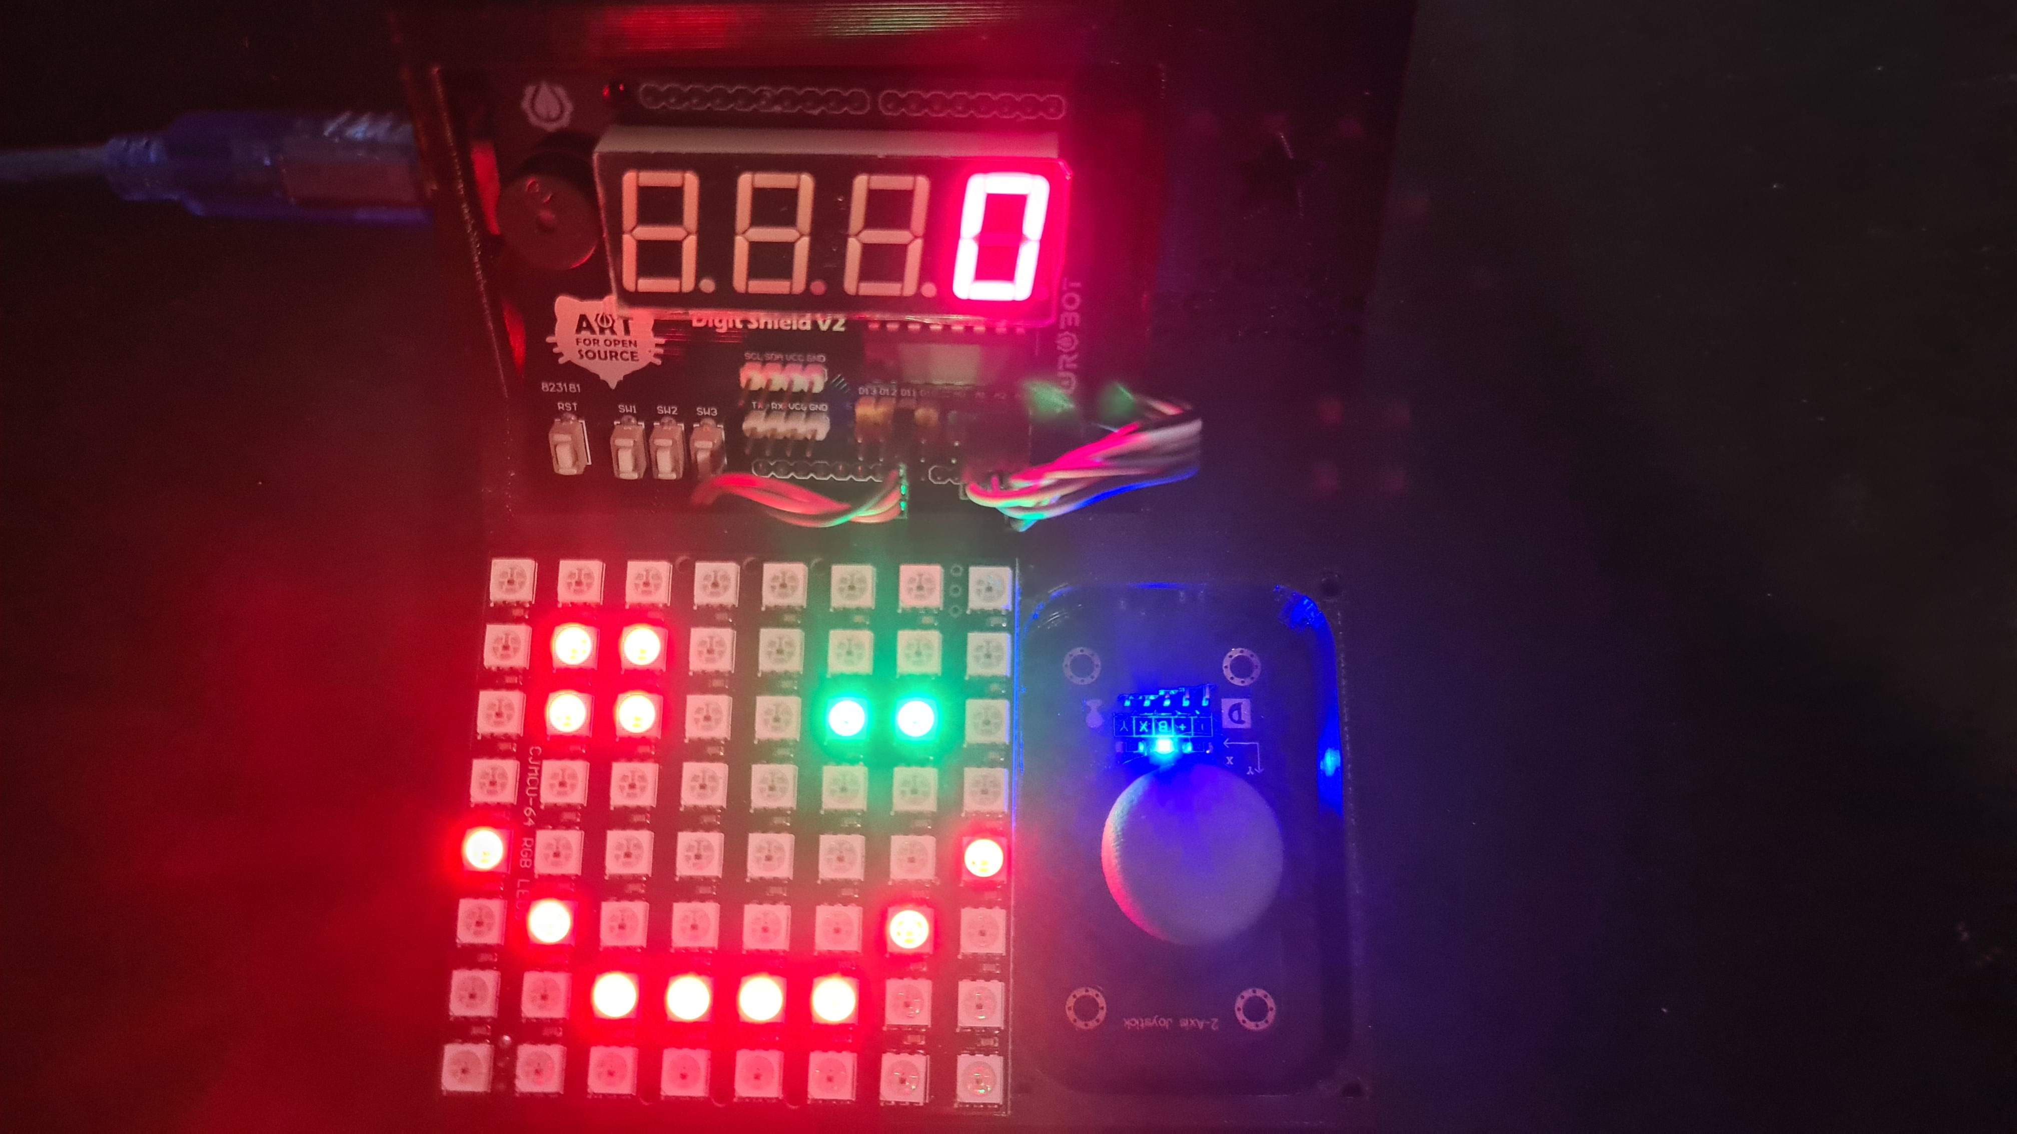

The code for this is on the next page.

Challenge Task:

Get the 8x8 matrix do this:

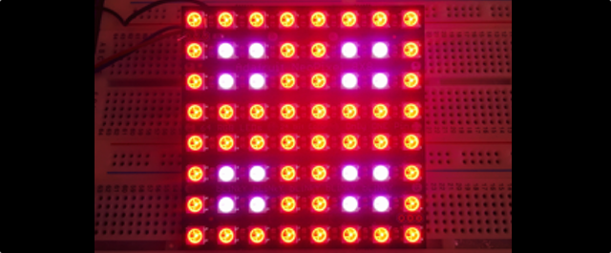

#include <DigitShield.h>

#include <Adafruit_NeoMatrix.h>

Adafruit_NeoMatrix matrix = Adafruit_NeoMatrix(8, 8, 11,

 NEO_MATRIX_TOP    + NEO_MATRIX_LEFT +

 NEO_MATRIX_COLUMNS + NEO_TILE_PROGRESSIVE,

 NEO_GRB            + NEO_KHZ800);

// Colours

int WHITE = matrix.Color(255,255,255);

int BLACK = matrix.Color(0,0,0);

int RED = matrix.Color(255,0,0);

int BLUE = matrix.Color(0,0,255);

int GREEN = matrix.Color(0,255,0);

int YELLOW = matrix.Color(255,255,0);

int AQUA = matrix.Color(0,255,255);

int PURPLE = matrix.Color(255,0,255);

void setup() {

 // put your setup code here, to run once:

 matrix.begin();

 matrix.setBrightness(20);

}

void loop() {

 // put your main code here, to run repeatedly:

 // Normal happy face

 matrix.fillScreen(0);          // Turn off all the LEDs

 matrix.fillRect(1,5,2,2,RED);  // Left Eye

 matrix.fillRect(5,5,2,2,RED);  // Right Eye

 // Mouth

 matrix.drawLine(2,1,5,1,RED);  // Bottom of mouth

 matrix.drawPixel(0,3,RED);

 matrix.drawPixel(1,2,RED);

 matrix.drawPixel(6,2,RED);

 matrix.drawPixel(7,3,RED);

 matrix.show();

 delay(800);

 // Winking happy face

 matrix.fillScreen(0);   // Turn off all the LEDs

 matrix.fillRect(1,5,2,2,RED);  // Left Eye

 matrix.drawLine(5,5,6,5,GREEN);// Right Winking Eye

 // Mouth

 matrix.drawLine(2,1,5,1,RED);  // Bottom of mouth

 matrix.drawPixel(0,3,RED);

 matrix.drawPixel(1,2,RED);

 matrix.drawPixel(6,2,RED);

 matrix.drawPixel(7,3,RED);

 matrix.show();

 delay(400);

}

# Arduino Digitshield and Matrix Graphics

This will display different graphics using the Digitshield and the 8x8 LED matrix.

#include <DigitShield.h>

#include <Adafruit_NeoMatrix.h>

Adafruit_NeoMatrix matrix = Adafruit_NeoMatrix(8, 8, 11,

 NEO_MATRIX_TOP    + NEO_MATRIX_LEFT +

 NEO_MATRIX_COLUMNS + NEO_TILE_PROGRESSIVE,

 NEO_GRB            + NEO_KHZ800);

// Colours

int WHITE = matrix.Color(255,255,255);

int BLACK = matrix.Color(0,0,0);

int RED = matrix.Color(255,0,0);

int BLUE = matrix.Color(0,0,255);

int GREEN = matrix.Color(0,255,0);

int YELLOW = matrix.Color(255,255,0);

int AQUA = matrix.Color(0,255,255);

int PURPLE = matrix.Color(255,0,255);

void setup() {

 // put your setup code here, to run once:

 DigitShield.begin();

 matrix.begin();

 matrix.setBrightness(40);

 DigitShield.setValue(7777);

}

void loop() {

 // Explosion graphics

 for (int i = 0; i < 5; i++) {

   matrix.fillScreen(0);

   matrix.fillCircle(4, 4, i, RED);

   matrix.show();

   delay(500);

 }

 // Blink score counter

 for (int j = 0; j < 3; j++) {

   DigitShield.setBlank(true);

   delay(250);

   DigitShield.setBlank(false);

   delay(250);

 }

 delay(1000);

}

# Arduino Joystick Calibration

This code can be used to calibrate the joystick, by printing the maximum and minimum values to the Serial Monitor.

#include <Adafruit_NeoMatrix.h>

Adafruit_NeoMatrix matrix = Adafruit_NeoMatrix(8, 8, 11,

 NEO_MATRIX_TOP    + NEO_MATRIX_LEFT +

 NEO_MATRIX_COLUMNS + NEO_TILE_PROGRESSIVE,

 NEO_GRB            + NEO_KHZ800);

// Colours

int WHITE = matrix.Color(255,255,255);

const byte PIN_ANALOG_X = 3;

const byte PIN_ANALOG_Y = 2;

int analogX;

int analogY;

int myx;

int myy;

int dt = 0;

// Edit these

int scaleX = 900;

int scaleY = 900;

void setup() {

 // put your setup code here, to run once:

 matrix.begin();

 matrix.setBrightness(20);

**Serial**.begin(9600);

 dt = 0;

}

void loop() {

 // put your main code here, to run repeatedly:

 // Get Joystick X and Y values

 analogX = analogRead(PIN_ANALOG_X);

 analogY = analogRead(PIN_ANALOG_Y);

 // Print X and Y values to Serial Monitor

 // But only once every second

 dt = dt + 1;

 if (dt > 20)

 {

**Serial**.print("Joystick X = ");

**Serial**.println(analogX);

**Serial**.print("Joystick Y = ");

**Serial**.println(analogY);

   dt = 0;

 }

 // Change X and Y values to match scale 0 to 7

 myx = map(analogX, 0, scaleX, 7, 0);

 myy = map(analogY, 0, scaleY, 0, 7);

 // Display the dot of where the joystick is pointing.

 matrix.fillScreen(0);

 matrix.drawPixel(myx,myy, WHITE);

 matrix.show();

 // Wait a short time before doing it again

 delay(50);

}

# Arduino Arcade – Pong

This is the classic Arcade game called Pong, one of the first every made video games.

A ball will bounce on the screen, and you must use the joystick to move the bat so that the ball does not hit the ground. You get more points the more you hit the ball, and at 15 hits in a row you win!

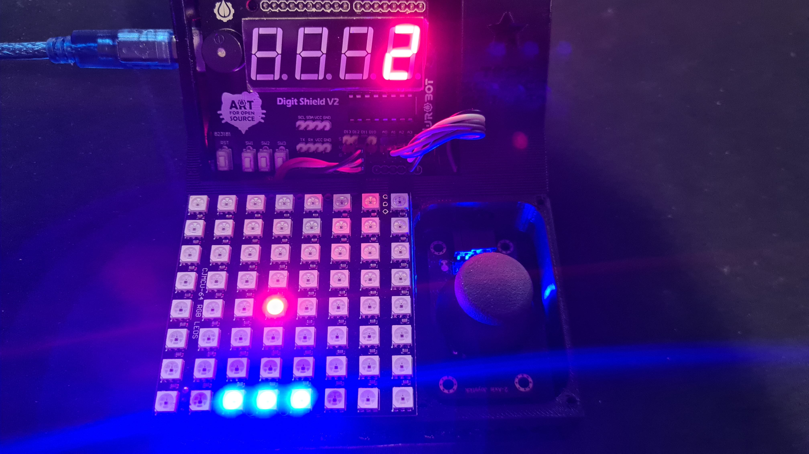  
  
This code is long and will go over the next 3 pages.

Code Page 1

#include <DigitShield.h>

#include <Adafruit_NeoMatrix.h>

Adafruit_NeoMatrix matrix = Adafruit_NeoMatrix(8, 8, 11,

 NEO_MATRIX_TOP    + NEO_MATRIX_LEFT +

 NEO_MATRIX_COLUMNS + NEO_TILE_PROGRESSIVE,

 NEO_GRB            + NEO_KHZ800);

// Colours

int WHITE = matrix.Color(255,255,255);

int BLACK = matrix.Color(0,0,0);

int RED = matrix.Color(255,0,0);

int BLUE = matrix.Color(0,0,255);

int GREEN = matrix.Color(0,255,0);

int YELLOW = matrix.Color(255,255,0);

int AQUA = matrix.Color(0,255,255);

int PURPLE = matrix.Color(255,0,255);

const byte PIN_ANALOG_X = 3;

const byte PIN_ANALOG_Y = 2;

int analogX = 0;

int myx = 0;

int myxleft = 0;

int myxright = 0;

int myy = 0;

int score = 0;

int mscount = 0;

int gamespeed = 160;

int gamespeedchange = 10;

int ballx = 0;

int bally = 1;

int ballvx = 1;

int ballvy = 1;

// Change bat size to 1, 2, or 3 for difficulty setting.

int mysize = 3;

void setup() {

 // put your setup code here, to run once:

 DigitShield.begin();

 matrix.begin();

 matrix.setBrightness(20);

 randomSeed(analogRead(0));

 ballx = random(0, 7);

 ballvx = random(-1, 1);

 bally = 1;

 ballvy = 1;

}

Code Page 2

void loop() {

 // put your main code here, to run repeatedly:

 DigitShield.setValue(score);

 analogX = analogRead(PIN_ANALOG_X);

 myx = map(analogX, 0, 850, 6, 0);

 if (mysize == 3) {  // Bat size 3

   myxleft = myx - 1;

   myxright = myx + 1;

 }

 else if (mysize == 2) {  // Bat size 2

   myxleft = myx;

   myxright = myx + 1;

 }

 else if (mysize == 1) {  // Bat size 1

   myxleft = myx;

   myxright = myx;

 }

 else {  // Only allow bat sizes between 1 and 3

   mysize = 3;

   return;

 }

 // mscount states how many 'loops' will it take to create a new frame

 mscount++;

 if (mscount > gamespeed) {  // Create new frame

   mscount = 0;

   // Bounce ball off the walls

   if (ballvx > 0 && (ballx + 1) > 7) {

     ballvx = -ballvx;

   }

   else if (ballvx < 0 && (ballx - 1) < 0) {

     ballvx = -ballvx;

   }

   ballx = ballx + ballvx;

   // Bounce the ball off the roof

   if (ballvy > 0 && (bally + 1) > 7) {

     ballvy = -ballvy;

   }

   bally = bally + ballvy;

Code Page 3

if (ballvy < 0 && bally == 1) {

     // Check if ball is on top of the bat

     if (ballx <= myxright && ballx >= myxleft) {

       // If the bat is only 1 pixel size, bounce the ball normally

       if (mysize == 1) {

       }

       // If on the right of the bat, bounce the ball right

       if (ballx == myxright) {

         ballvx = 1;

       }

       // If on the left of the bat, bounce the ball left

       else if (ballx == myxleft) {

         ballvx = -1;

       }

       else {  // If in the middle of the bat, bounce normally

       }

       ballvy = -ballvy;

       score++;

       gamespeed = gamespeed - gamespeedchange;

     }

   }

   else if (bally < 1) {   // Ball missed the bat. Game over!

     score = 0;

     gamespeed = 160;

     ballx = random(0, 7);

     ballvx = random(-1, 1);

     bally = 1;

     ballvy = 1;

   }

 }

 if (score == 15) {    // WIN!

   matrix.fillScreen(0);

   gamespeed = 160;

   score = 0;

   ballx = random(0, 7);

   ballvx = random(-1, 1);

   bally = 1;

   ballvy = 1;

 }

 matrix.fillScreen(0);

 matrix.drawPixel(myx,myy, BLUE);

 matrix.drawPixel(myxright,myy, BLUE);

 matrix.drawPixel(myxleft,myy, BLUE);

 matrix.drawPixel(ballx,bally, RED);

 matrix.show();

}

# Arduino Arcade – Space Invaders Part 1

This is a classic Arcade game called Space Invaders. You are a spaceship with aliens flying to you.

Using your joystick, you move your spaceship left and right. You can press down on the joystick to shoot to fire a bullet that will destroy the alien on hit.

You win if you shoot enough aliens before they get to your spaceship, however they move faster every time you hit one!

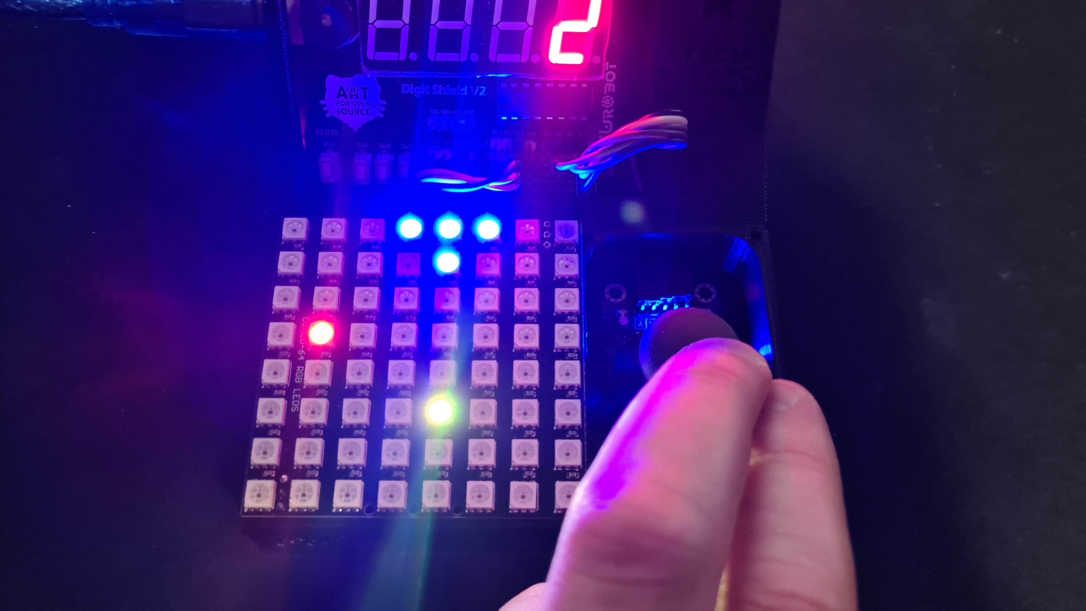  
  
This code is long and will go over the next 3 pages.

#include <DigitShield.h>

#include <Adafruit_NeoMatrix.h>

Adafruit_NeoMatrix matrix = Adafruit_NeoMatrix(8, 8, 11,

 NEO_MATRIX_TOP    + NEO_MATRIX_LEFT +

 NEO_MATRIX_COLUMNS + NEO_TILE_PROGRESSIVE,

 NEO_GRB            + NEO_KHZ800);

// Colours

int WHITE = matrix.Color(255,255,255);

int BLACK = matrix.Color(0,0,0);

int RED = matrix.Color(255,0,0);

int BLUE = matrix.Color(0,0,255);

int GREEN = matrix.Color(0,255,0);

int YELLOW = matrix.Color(255,255,0);

int AQUA = matrix.Color(0,255,255);

int PURPLE = matrix.Color(255,0,255);

const byte PIN_ANALOG_X = 3;

const byte PIN_ANALOG_Y = 2;

int myx = 0;

int myy = 7;

int score = 0;

int enemyx = 0;

int enemyy = 0;

int mscount = 0;

int bulletx = 10;

int bullety = 10;

int firebutton = 0;

int gamespeed = 80;

void setup() {

//  pinMode(buzzerPin, OUTPUT);

 DigitShield.begin();

 matrix.begin();

 matrix.setBrightness(20);

}

void loop() {

 DigitShield.setValue(score);

 myx = analogRead(PIN_ANALOG_X);

 myx = map(myx, 0, 900, 7, 0);

 firebutton = digitalRead(A1);

 // When Shooting

 if (firebutton == 1) {

   bulletx = myx;

   bullety = myy-2;

 }

  // loop counter

 mscount++;

Code Page 1

Code Page 2

 if (mscount > gamespeed) {  // Create new frame

   mscount = 0;

   enemyx++;

   bullety--;

 }

 // When hitting enemy

 if (bulletx == enemyx && bullety == enemyy) {

   score++;

   enemyy = 0;

   enemyx = 0;

   bullety = -1;               // Make bullet dissapear

   gamespeed = gamespeed - 10; // Make it faster

 }

 // When enemy gets to the edge of the screen

 if (enemyx > 7){

   enemyx = 0;

   enemyy++;

 }

 if (enemyy >= 6){   // Lose a point

   enemyy = 0;

   score--;

   gamespeed = gamespeed + 10;

 }

 if (score < 0){     // Game over

   score = 0;

   gamespeed = 80;

 }

 if (score == 5){    // WIN!

   matrix.fillScreen(0);

   gamespeed = 80;

   score = 0;

 }

 matrix.fillScreen(0);

 matrix.drawPixel(myx,myy, BLUE);

 matrix.drawPixel(myx+1,myy, BLUE);

 matrix.drawPixel(myx-1,myy, BLUE);

 matrix.drawPixel(myx,myy-1, BLUE);

 matrix.drawPixel(enemyx,enemyy, RED);

 matrix.drawPixel(bulletx,bullety, YELLOW);

 matrix.show();

}

# Arduino Arcade – Space Invaders Part 2

This is the same as the last, but with some improvements, bugfixes, and extra graphics.  
  
  
Code Page 1  
  
  
Code Page 2

#include <DigitShield.h>

#include <Adafruit_NeoMatrix.h>

Adafruit_NeoMatrix matrix = Adafruit_NeoMatrix(8, 8, 11,

 NEO_MATRIX_TOP    + NEO_MATRIX_LEFT +

 NEO_MATRIX_COLUMNS + NEO_TILE_PROGRESSIVE,

 NEO_GRB            + NEO_KHZ800);

// Colours

int WHITE = matrix.Color(255,255,255);

int BLACK = matrix.Color(0,0,0);

int RED = matrix.Color(255,0,0);

int BLUE = matrix.Color(0,0,255);

int GREEN = matrix.Color(0,255,0);

int YELLOW = matrix.Color(255,255,0);

int AQUA = matrix.Color(0,255,255);

int PURPLE = matrix.Color(255,0,255);

const byte PIN_ANALOG_X = 3;

const byte PIN_ANALOG_Y = 2;

int myx = 0;

int myy = 7;

int score = 0;

int enemyx = 0;

int enemyy = 0;

int mscount = 0;

int bulletx = 10;

int bullety = -1;

int firebutton = 0;

int gamespeed = 80;

void setup() {

//  pinMode(buzzerPin, OUTPUT);

 DigitShield.begin();

 matrix.begin();

 matrix.setBrightness(20);

}

void loop() {

 DigitShield.setValue(score);

 myx = analogRead(PIN_ANALOG_X);

 myx = map(myx, 0, 900, 7, 0);

 firebutton = digitalRead(A1);

 // When Shooting, only allow shoot if:

 // - bullet has hit enemy or,

 // - bullet has hit the bottom of the screen

 if (firebutton == 1 && bullety < 0) {

   bulletx = myx;

   bullety = myy-2;

 }

  // Loop counter

 mscount++;

 if (mscount > gamespeed) {  // Create new frame

   mscount = 0;

   enemyx++;

   bullety--;

 }

 // When hitting enemy

 if (bulletx == enemyx && bullety == enemyy) {

   score++;

   DigitShield.setValue(score);

   // Explode enemy

   matrix.fillScreen(0);

   matrix.drawPixel(myx,myy, BLUE);

   matrix.drawPixel(myx+1,myy, BLUE);

   matrix.drawPixel(myx-1,myy, BLUE);

   matrix.drawPixel(myx,myy-1, BLUE);

   matrix.fillCircle(enemyx, enemyy, 1, RED);

   matrix.show();

   // WIN if enemy hit and then Score is 5

   if (score == 5) {

     // Blink score counter

     DigitShield.setBlank(true);

     delay(250);

     DigitShield.setBlank(false);

     delay(250);

     DigitShield.setBlank(true);

     delay(250);

     DigitShield.setBlank(false);

     delay(250);

     DigitShield.setBlank(true);

     delay(250);

     DigitShield.setBlank(false);

     delay(250);

     gamespeed = 80;

     score = 0;

   }

    delay(250);

   bullety = -1;        // Make bullet disappear

   enemyy = 0;

   enemyx = 0;

   gamespeed = gamespeed - 10; // Make it faster

 }

 if (bullety < 0) {

   bullety = -1;

 }

Code Page 3

  // When enemy gets to the edge of the screen

 if (enemyx > 7){

   enemyx = 0;

   enemyy++;

 }

 if (enemyy >= 6){   // Lose a point

   enemyy = 0;

   score--;

   gamespeed = gamespeed + 10;

 }

 if (score < 0){     // Game over

   score = 0;

   gamespeed = 80;

   // Explode Spaceship of game over

   for (int i = 2; i < 7; i++) {

     matrix.fillScreen(0);

     matrix.fillCircle(myx, myy, i, RED);

     matrix.show();

     delay(500);

   }

 }

 matrix.fillScreen(0);

 matrix.drawPixel(myx,myy, BLUE);

 matrix.drawPixel(myx+1,myy, BLUE);

 matrix.drawPixel(myx-1,myy, BLUE);

 matrix.drawPixel(myx,myy-1, BLUE);

 matrix.drawPixel(bulletx,bullety, WHITE);

 matrix.drawPixel(enemyx,enemyy, RED);

 matrix.show();

}